China Issue
Issue:1- Image is missing.
Old link:- https://www.carlsbergchina.com.cn/zh/
New link:- https://stage-carlsberg-group-2022.euwest01.umbraco.io/asia/cn/zh/
Old Image:
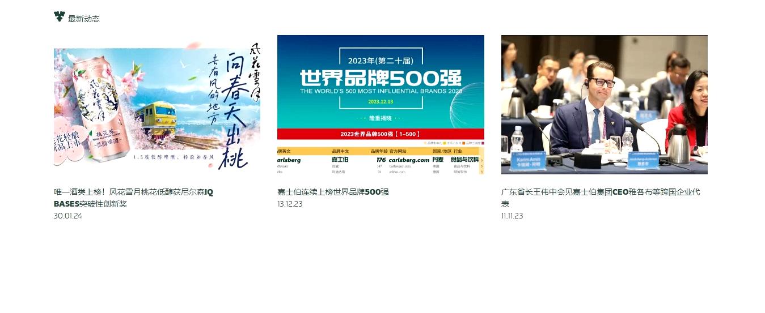
New Image:-
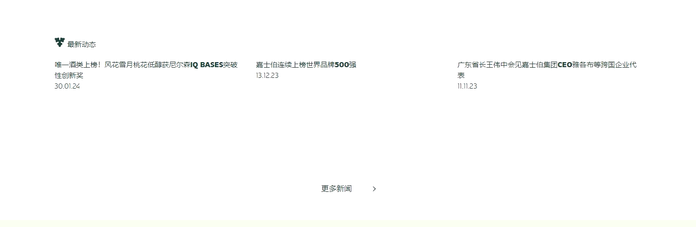

Issue:2- Image is missing.
Old link:- https://www.carlsbergchina.com.cn/zh/
New link:- https://stage-carlsberg-group-2022.euwest01.umbraco.io/asia/cn/zh/
Old image:
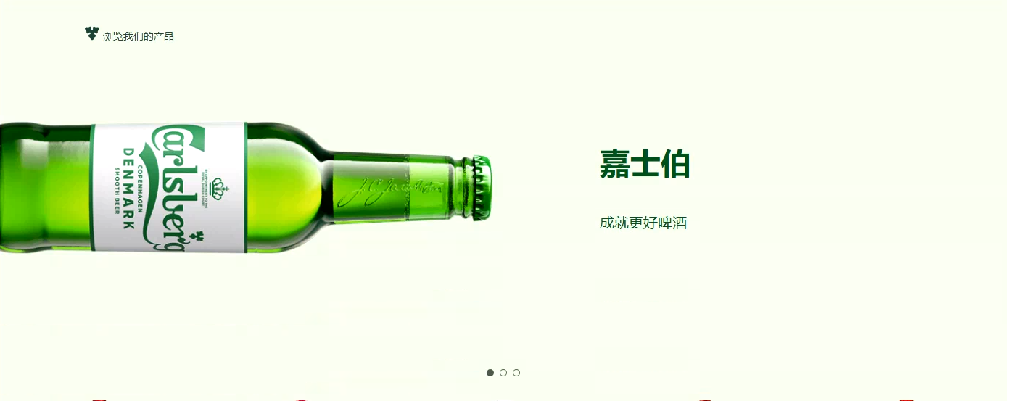
New Image:

Issue 3: language is different.
Old link:- https://www.carlsbergchina.com.cn/zh/
New link:- https://stage-carlsberg-group-2022.euwest01.umbraco.io/asia/cn/zh/
Old image:
New image:
Issue 4: image is missing.
Old link:- https://www.carlsbergchina.com.cn/zh/
New link:- https://stage-carlsberg-group-2022.euwest01.umbraco.io/asia/cn/zh/
Old image:
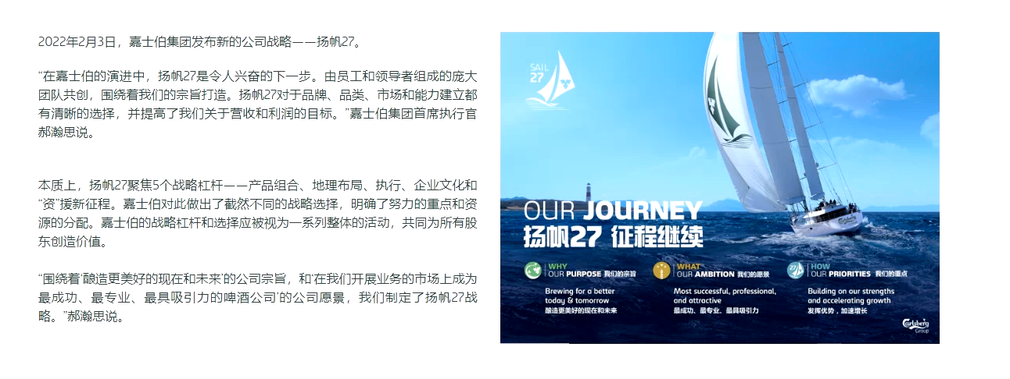
New image:
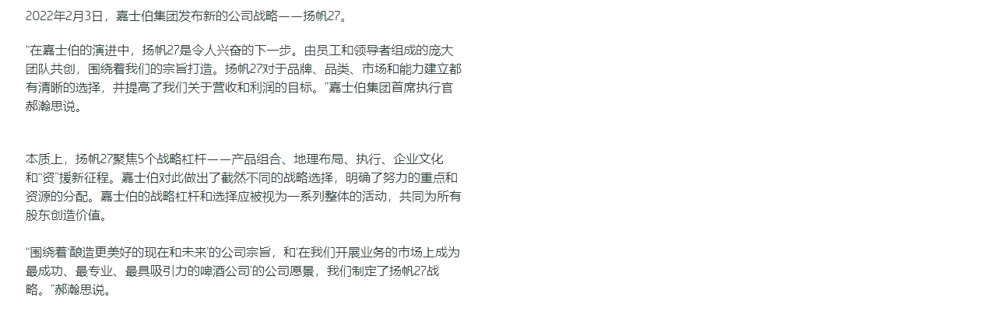
Issue 5: Given link is incorrect.
Old link: https://www.carlsbergchina.com.cn/zh/
New link: https://stage-carlsberg-group-2022.euwest01.umbraco.io/asia/cn/zh/
Old image:
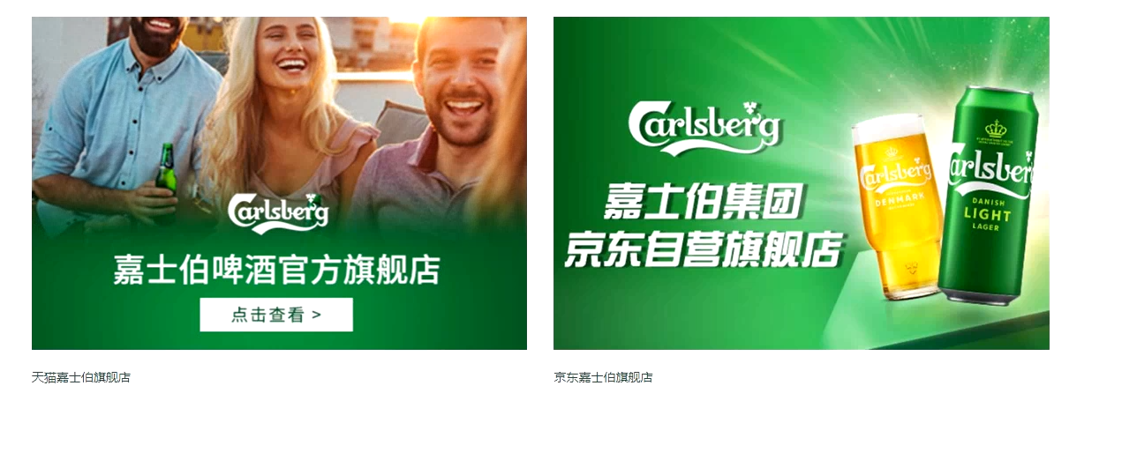
New image:
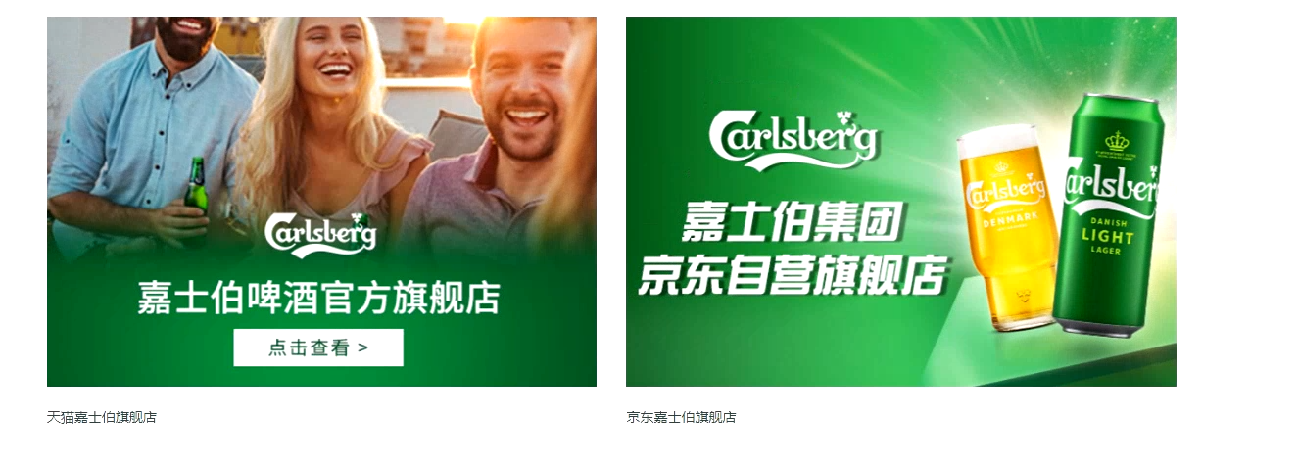

Issue 6: Language is different.
Old link: https://www.carlsbergchina.com.cn/zh/
New link: https://stage-carlsberg-group-2022.euwest01.umbraco.io/asia/cn/zh/
Old image:
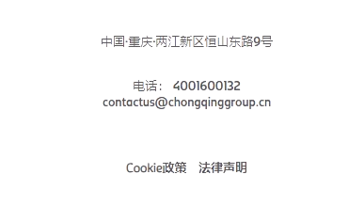
New image:
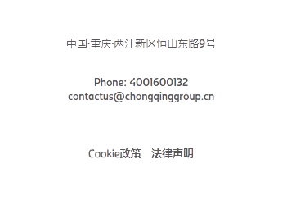

Issue 7: Content alignment is incorrect.
Old link: https://www.carlsbergchina.com.cn/zh/%E5%85%AC%E5%8F%B8%E7%AE%80%E4%BB%8B/%E9%87%8D%E5%95%A4%E8%82%A1%E4%BB%BD/%E5%8F%91%E5%B1%95%E5%8E%86%E7%A8%8B/
New link: https://stage-carlsberg-group-2022.euwest01.umbraco.io/asia/cn/zh/%E5%85%AC%E5%8F%B8%E7%AE%80%E4%BB%8B/%E9%87%8D%E5%95%A4%E8%82%A1%E4%BB%BD/%E5%8F%91%E5%B1%95%E5%8E%86%E7%A8%8B/
Old image:
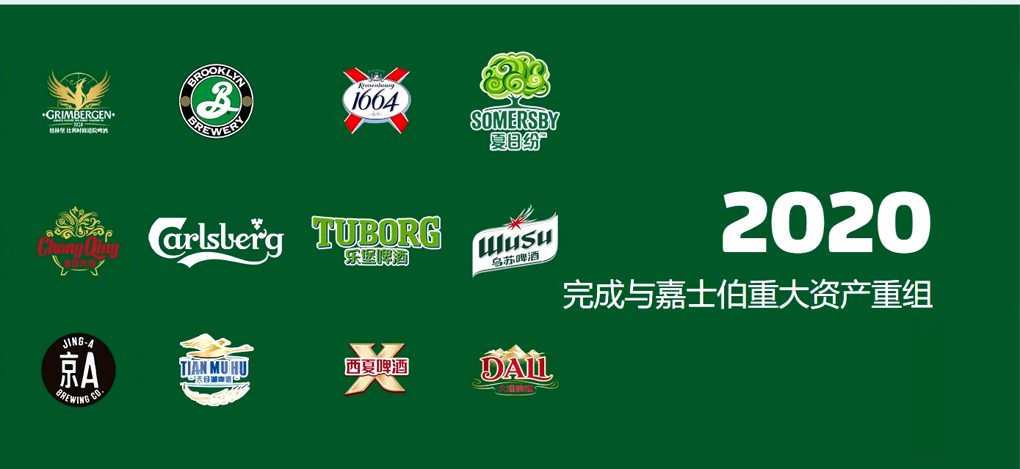
New image:
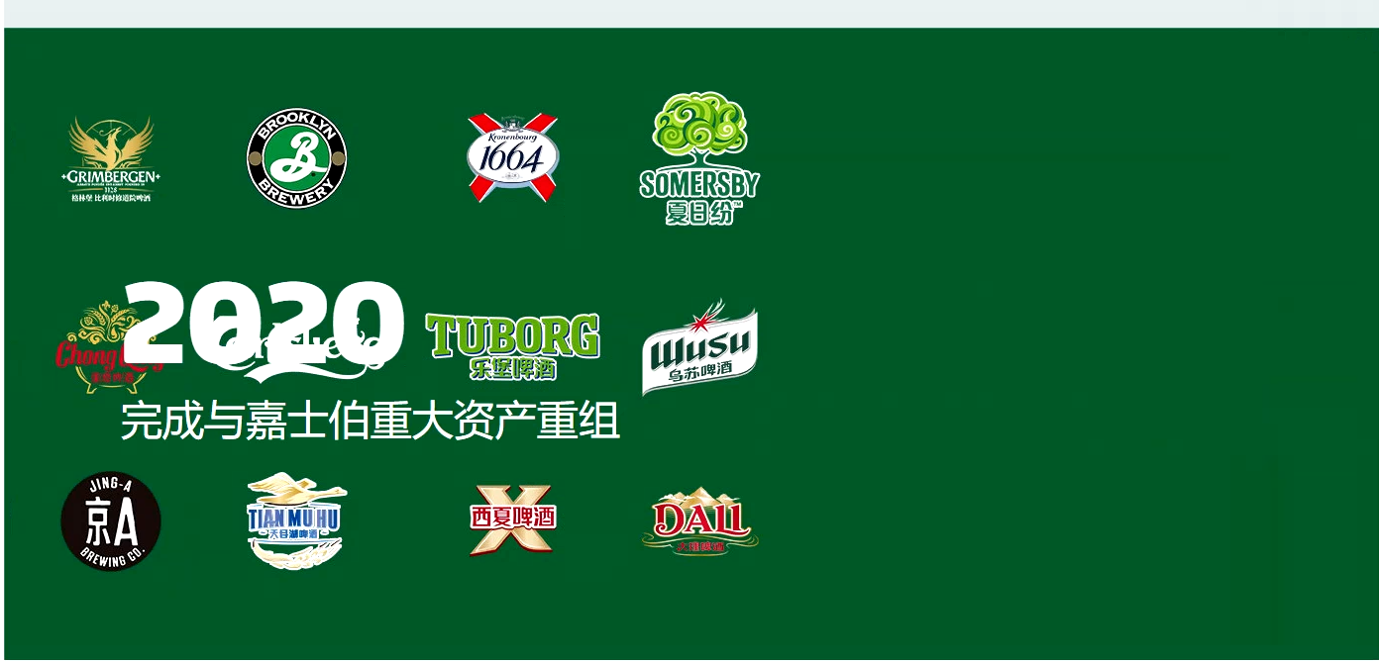

Issue 8: Content alignment is incorrect.
Old link: https://www.carlsbergchina.com.cn/zh/%E5%85%AC%E5%8F%B8%E7%AE%80%E4%BB%8B/%E5%98%89%E5%A3%AB%E4%BC%AF%E9%9B%86%E5%9B%A2/
New link: https://stage-carlsberg-group-2022.euwest01.umbraco.io/asia/cn/zh/%E5%85%AC%E5%8F%B8%E7%AE%80%E4%BB%8B/%E5%98%89%E5%A3%AB%E4%BC%AF%E9%9B%86%E5%9B%A2/
Old image:
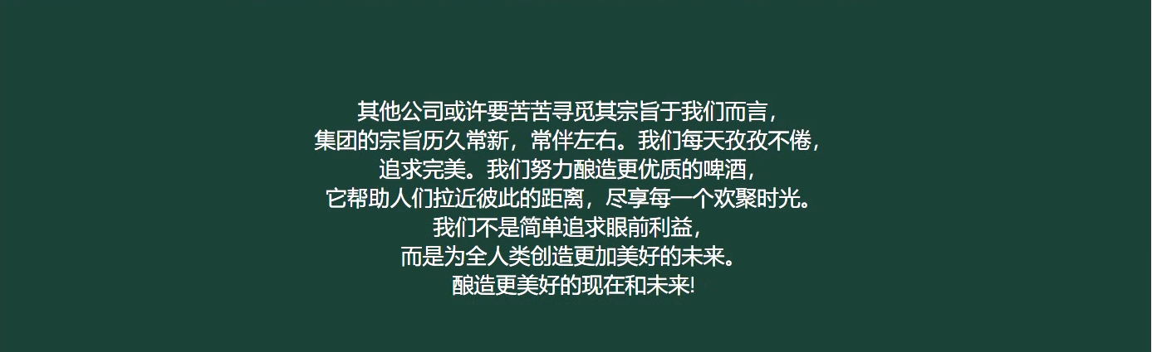
New image:
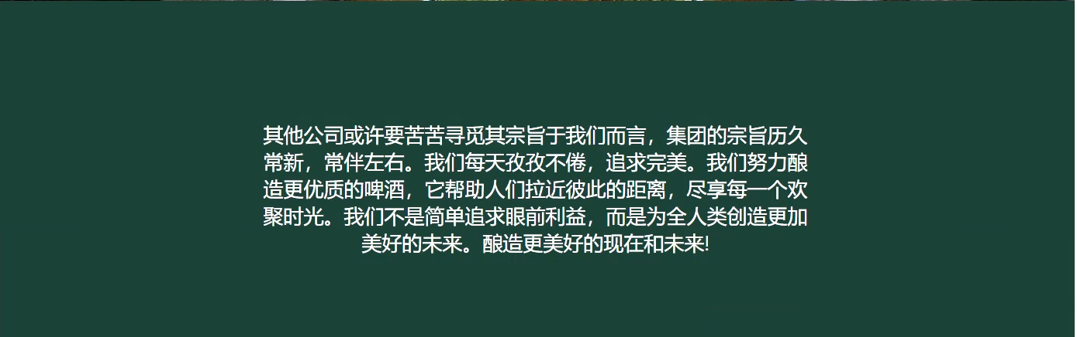

Issue 9: Code ISSue
Old link: https://www.carlsbergchina.com.cn/zh/%E5%85%AC%E5%8F%B8%E7%AE%80%E4%BB%8B/%E5%98%89%E5%A3%AB%E4%BC%AF%E9%9B%86%E5%9B%A2/%E6%88%91%E4%BB%AC%E7%9A%84%E4%BC%A0%E6%89%BF/
New link: https://stage-carlsberg-group-2022.euwest01.umbraco.io/asia/cn/zh/%E5%85%AC%E5%8F%B8%E7%AE%80%E4%BB%8B/%E5%98%89%E5%A3%AB%E4%BC%AF%E9%9B%86%E5%9B%A2/%E6%88%91%E4%BB%AC%E7%9A%84%E4%BC%A0%E6%89%BF/
Old image:
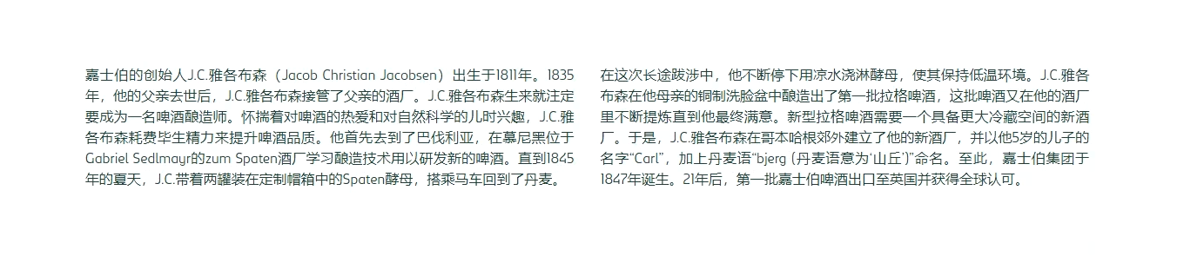
New image:
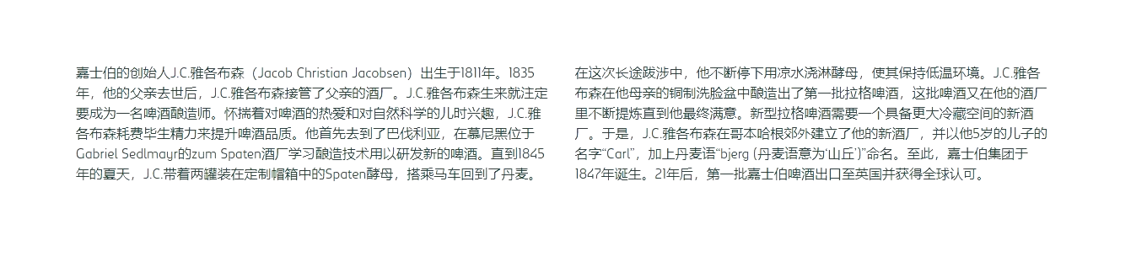

Issue 10: Image signature is missing.
Old link: https://www.carlsbergchina.com.cn/zh/%E5%85%AC%E5%8F%B8%E7%AE%80%E4%BB%8B/%E5%98%89%E5%A3%AB%E4%BC%AF%E9%9B%86%E5%9B%A2/%E6%88%91%E4%BB%AC%E7%9A%84%E4%BC%A0%E6%89%BF/
New link: https://stage-carlsberg-group-2022.euwest01.umbraco.io/asia/cn/zh/%E5%85%AC%E5%8F%B8%E7%AE%80%E4%BB%8B/%E5%98%89%E5%A3%AB%E4%BC%AF%E9%9B%86%E5%9B%A2/%E6%88%91%E4%BB%AC%E7%9A%84%E4%BC%A0%E6%89%BF/
Old image:
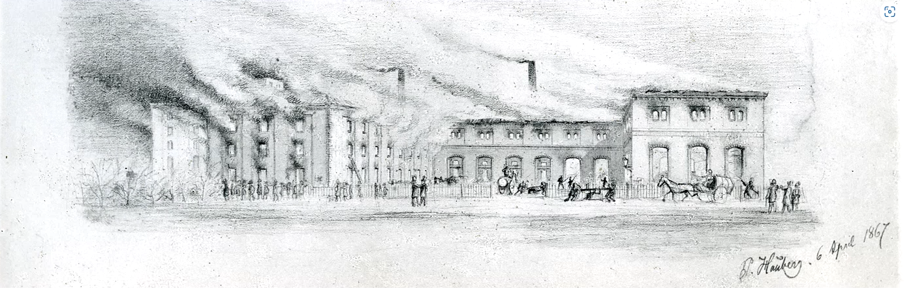
New image:
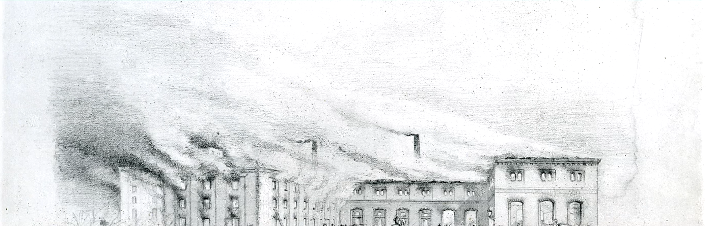

Issue 11: Text alignment is different.
Old link: https://www.carlsbergchina.com.cn/zh/%E5%85%AC%E5%8F%B8%E7%AE%80%E4%BB%8B/%E5%98%89%E5%A3%AB%E4%BC%AF%E9%9B%86%E5%9B%A2/%E6%88%91%E4%BB%AC%E7%9A%84%E4%BC%A0%E6%89%BF/
New link: https://stage-carlsberg-group-2022.euwest01.umbraco.io/asia/cn/zh/%E5%85%AC%E5%8F%B8%E7%AE%80%E4%BB%8B/%E5%98%89%E5%A3%AB%E4%BC%AF%E9%9B%86%E5%9B%A2/%E6%88%91%E4%BB%AC%E7%9A%84%E4%BC%A0%E6%89%BF/
Old image:
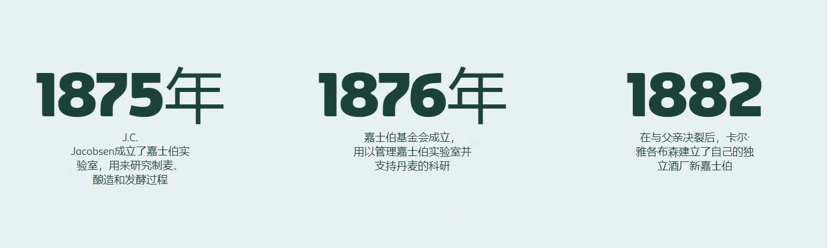
New image:
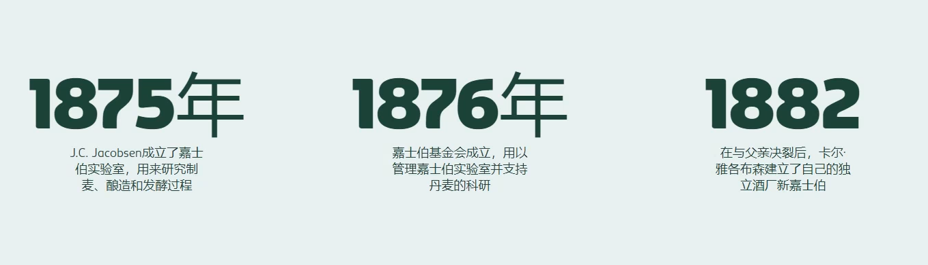

Issue 12: Text alignment is different.
Old link: https://www.carlsbergchina.com.cn/zh/%E5%85%AC%E5%8F%B8%E7%AE%80%E4%BB%8B/%E5%98%89%E5%A3%AB%E4%BC%AF%E9%9B%86%E5%9B%A2/%E6%88%91%E4%BB%AC%E7%9A%84%E4%BC%A0%E6%89%BF/
New link: https://www.carlsbergchina.com.cn/zh/%E5%85%AC%E5%8F%B8%E7%AE%80%E4%BB%8B/%E5%98%89%E5%A3%AB%E4%BC%AF%E9%9B%86%E5%9B%A2/%E6%88%91%E4%BB%AC%E7%9A%84%E4%BC%A0%E6%89%BF/
Old image:
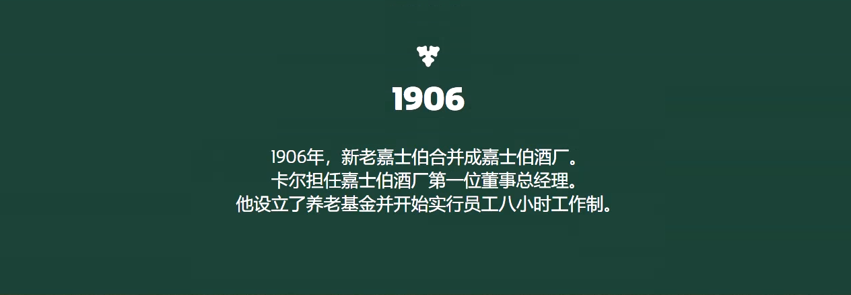
New image:
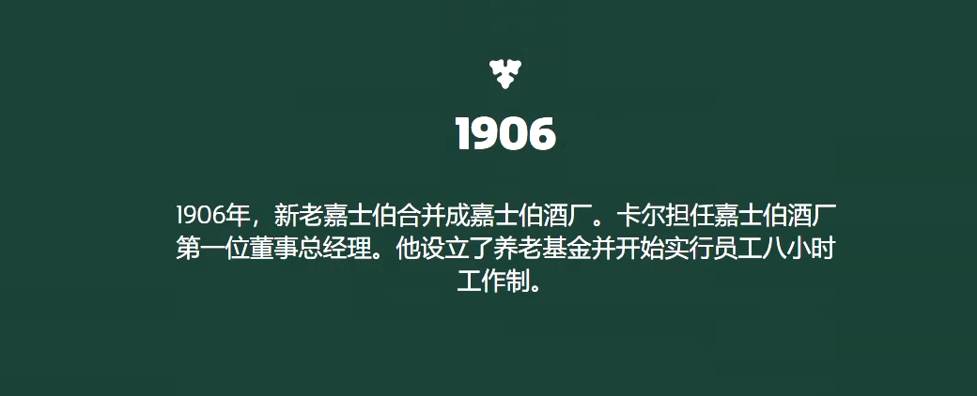

Issue 13: heading is missing.
Old link; https://stage-carlsberg-group-2022.euwest01.umbraco.io/asia/cn/zh/%E5%85%AC%E5%8F%B8%E7%AE%80%E4%BB%8B/%E5%98%89%E5%A3%AB%E4%BC%AF%E9%9B%86%E5%9B%A2/%E6%88%91%E4%BB%AC%E7%9A%84%E4%BC%A0%E6%89%BF/
New link: https://stage-carlsberg-group-2022.euwest01.umbraco.io/asia/cn/zh/%E5%85%AC%E5%8F%B8%E7%AE%80%E4%BB%8B/%E5%98%89%E5%A3%AB%E4%BC%AF%E9%9B%86%E5%9B%A2/%E6%88%91%E4%BB%AC%E7%9A%84%E4%BC%A0%E6%89%BF/
Old image:
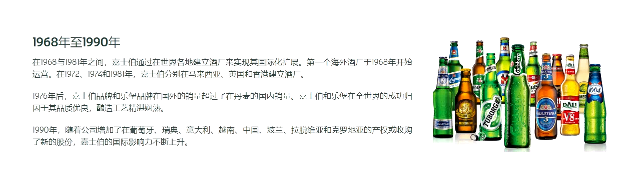
New image:
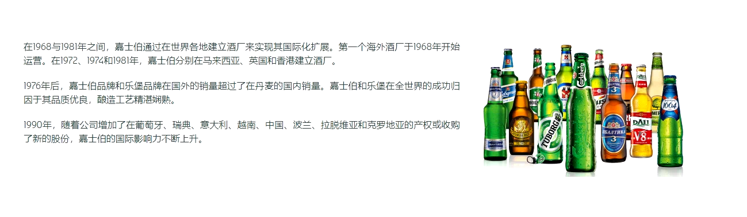

Issue 14: text alignment is different.
Old link; https://stage-carlsberg-group-2022.euwest01.umbraco.io/asia/cn/zh/%E5%85%AC%E5%8F%B8%E7%AE%80%E4%BB%8B/%E5%98%89%E5%A3%AB%E4%BC%AF%E9%9B%86%E5%9B%A2/%E6%88%91%E4%BB%AC%E7%9A%84%E4%BC%A0%E6%89%BF/
New link: https://stage-carlsberg-group-2022.euwest01.umbraco.io/asia/cn/zh/%E5%85%AC%E5%8F%B8%E7%AE%80%E4%BB%8B/%E5%98%89%E5%A3%AB%E4%BC%AF%E9%9B%86%E5%9B%A2/%E6%88%91%E4%BB%AC%E7%9A%84%E4%BC%A0%E6%89%BF/
Old image:
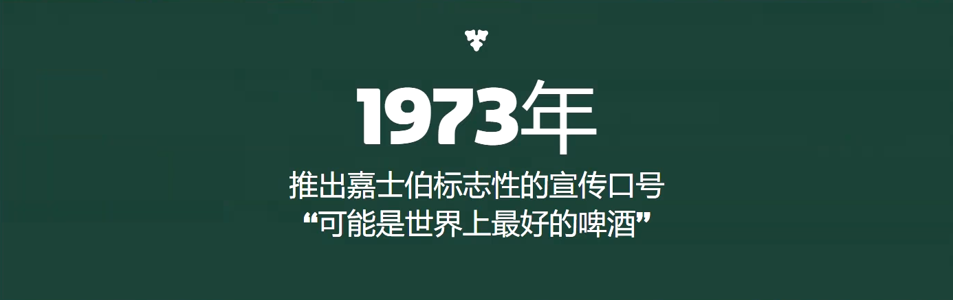
New image:
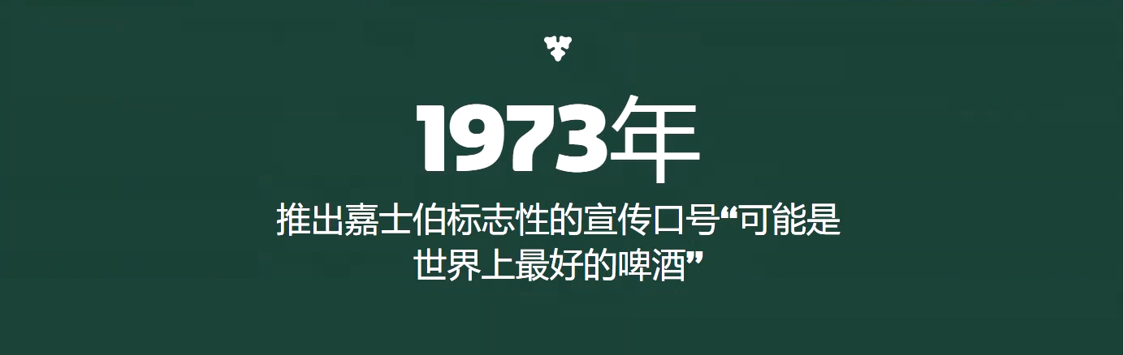

Issue 15: text alignment is different.
Old link; https://stage-carlsberg-group-2022.euwest01.umbraco.io/asia/cn/zh/%E5%85%AC%E5%8F%B8%E7%AE%80%E4%BB%8B/%E5%98%89%E5%A3%AB%E4%BC%AF%E9%9B%86%E5%9B%A2/%E6%88%91%E4%BB%AC%E7%9A%84%E4%BC%A0%E6%89%BF/
New link: https://stage-carlsberg-group-2022.euwest01.umbraco.io/asia/cn/zh/%E5%85%AC%E5%8F%B8%E7%AE%80%E4%BB%8B/%E5%98%89%E5%A3%AB%E4%BC%AF%E9%9B%86%E5%9B%A2/%E6%88%91%E4%BB%AC%E7%9A%84%E4%BC%A0%E6%89%BF/
Old image:
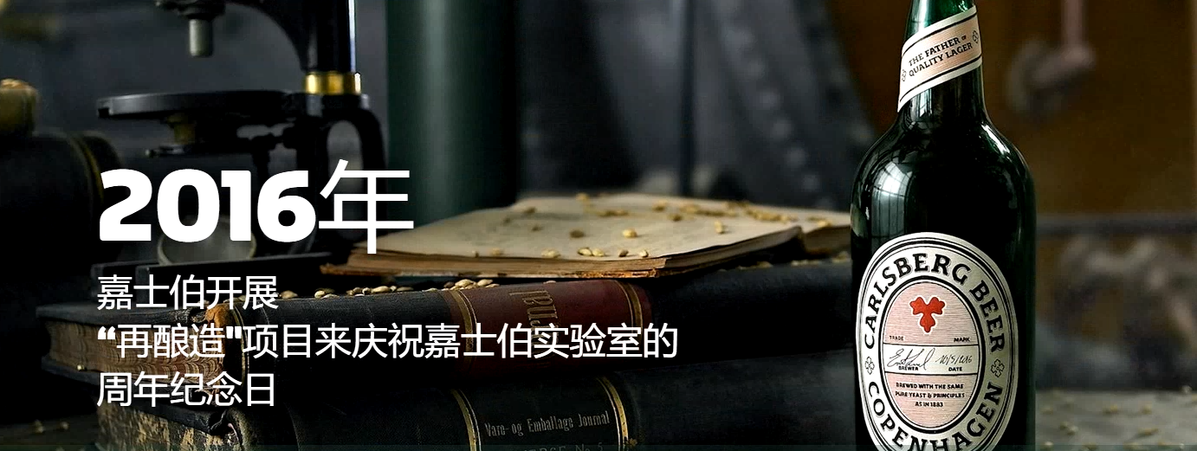
New image:
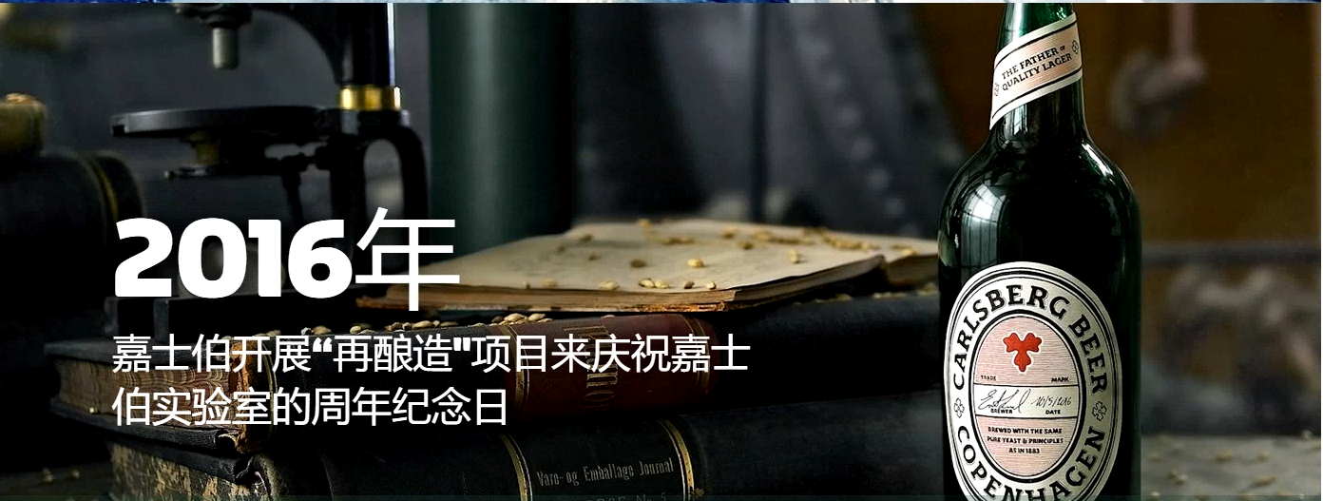

Issue 16:Focal point issue.
Old link: https://www.carlsbergchina.com.cn/zh/%E5%85%AC%E5%8F%B8%E7%AE%80%E4%BB%8B/%E5%98%89%E5%A3%AB%E4%BC%AF%E9%9B%86%E5%9B%A2/%E5%98%89%E5%A3%AB%E4%BC%AF%E4%BE%9B%E5%BA%94%E9%93%BE/
New link: https://stage-carlsberg-group-2022.euwest01.umbraco.io/asia/cn/zh/%E5%85%AC%E5%8F%B8%E7%AE%80%E4%BB%8B/%E5%98%89%E5%A3%AB%E4%BC%AF%E9%9B%86%E5%9B%A2/%E5%98%89%E5%A3%AB%E4%BC%AF%E4%BE%9B%E5%BA%94%E9%93%BE/
Old image:
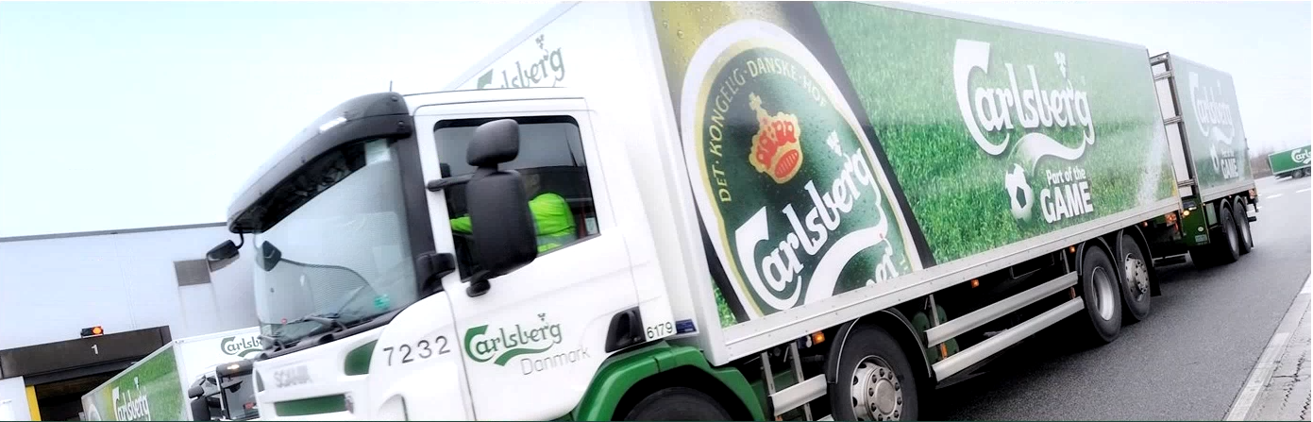
New image:
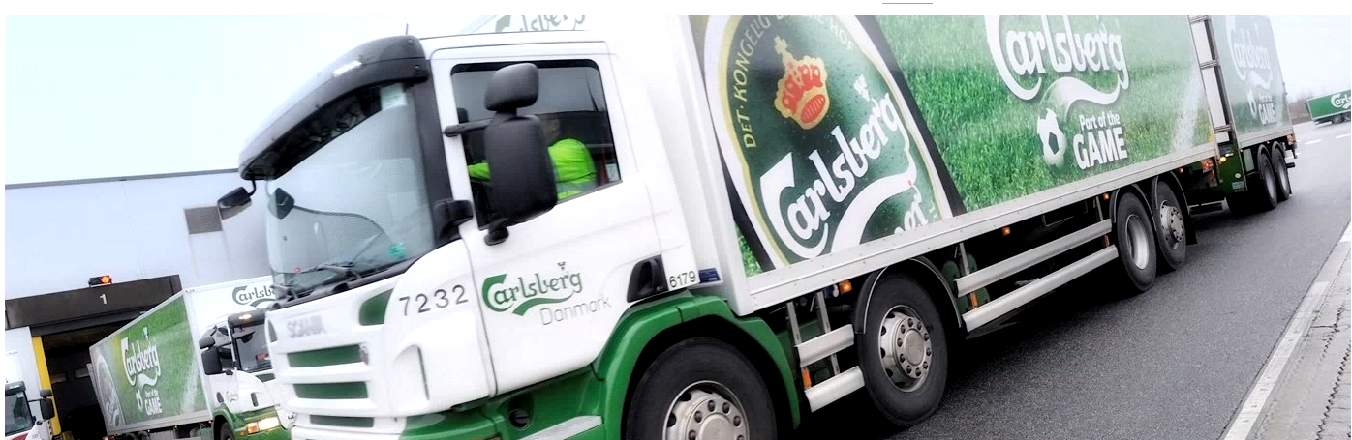

Issue 17: content alignment issue
Old link: https://www.carlsbergchina.com.cn/zh/%E5%85%AC%E5%8F%B8%E7%AE%80%E4%BB%8B/%E5%98%89%E5%A3%AB%E4%BC%AF%E9%9B%86%E5%9B%A2/%E5%98%89%E5%A3%AB%E4%BC%AF%E4%BE%9B%E5%BA%94%E9%93%BE/
New link: https://stage-carlsberg-group-2022.euwest01.umbraco.io/asia/cn/zh/%E5%85%AC%E5%8F%B8%E7%AE%80%E4%BB%8B/%E5%98%89%E5%A3%AB%E4%BC%AF%E9%9B%86%E5%9B%A2/%E5%98%89%E5%A3%AB%E4%BC%AF%E4%BE%9B%E5%BA%94%E9%93%BE/
Old image:
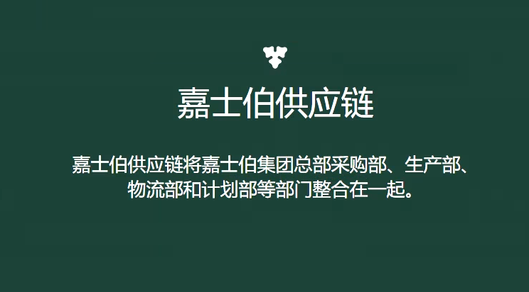
New image:
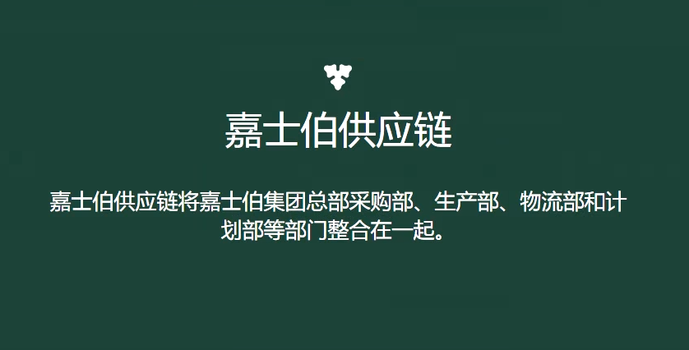

Issue 18: Pdf is not added.
Old link: https://www.carlsbergchina.com.cn/zh/%E5%85%AC%E5%8F%B8%E7%AE%80%E4%BB%8B/%E5%98%89%E5%A3%AB%E4%BC%AF%E9%9B%86%E5%9B%A2/%E5%98%89%E5%A3%AB%E4%BC%AF%E4%BE%9B%E5%BA%94%E9%93%BE/
New link: https://stage-carlsberg-group-2022.euwest01.umbraco.io/asia/cn/zh/%E5%85%AC%E5%8F%B8%E7%AE%80%E4%BB%8B/%E5%98%89%E5%A3%AB%E4%BC%AF%E9%9B%86%E5%9B%A2/%E5%98%89%E5%A3%AB%E4%BC%AF%E4%BE%9B%E5%BA%94%E9%93%BE/
Old image:
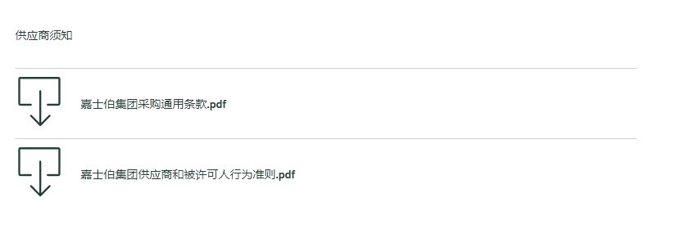
New image:
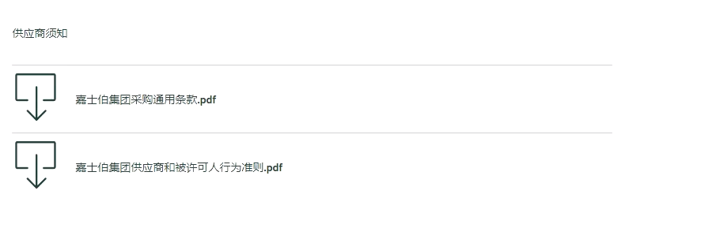

Issue 19: Language is different.
Old link: https://www.carlsbergchina.com.cn/zh/%E7%95%85%E9%94%80%E5%93%81%E7%89%8C/
New link: https://stage-carlsberg-group-2022.euwest01.umbraco.io/asia/cn/zh/%E7%95%85%E9%94%80%E5%93%81%E7%89%8C/
Old image:
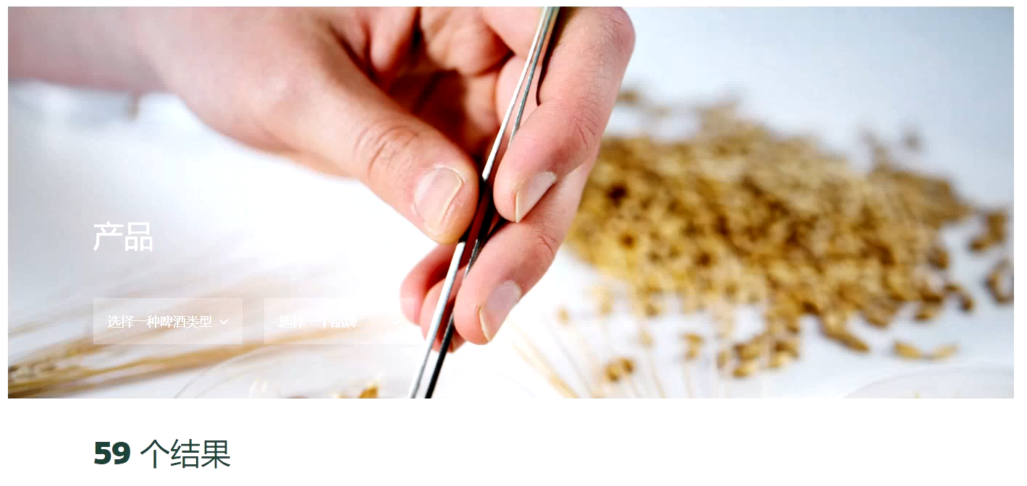
New image:
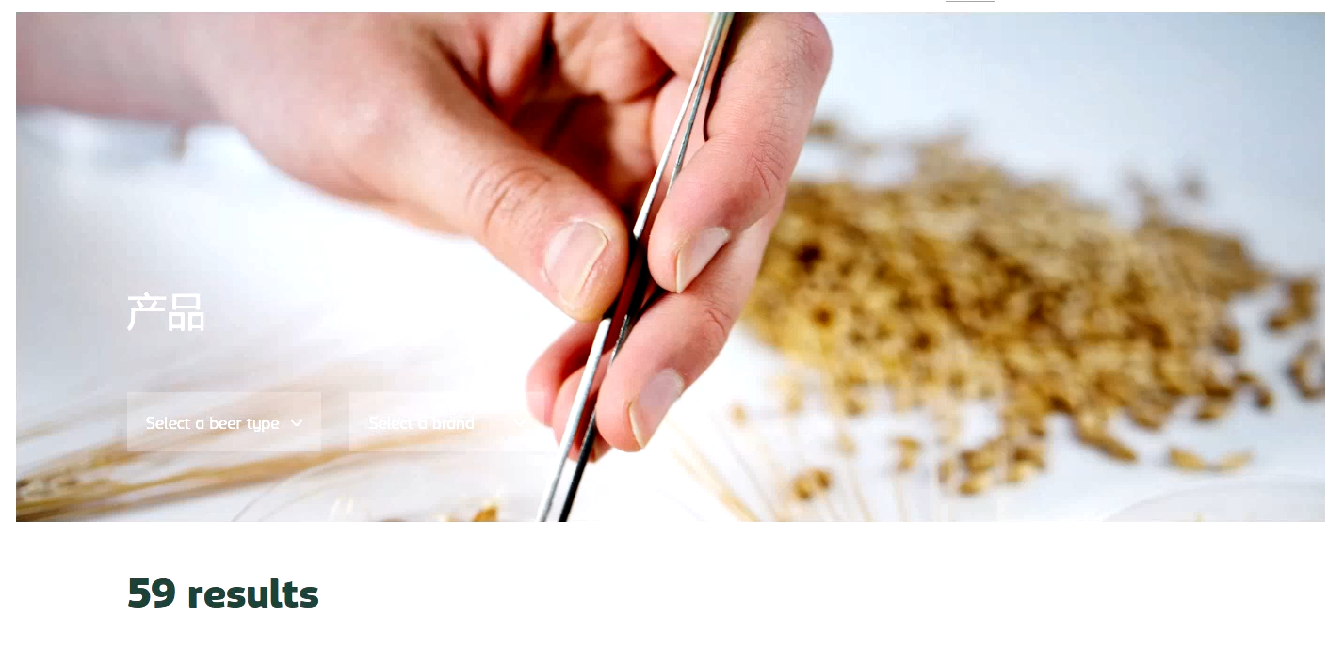

Issue 20: for beer type Language is different.
Old link: https://www.carlsbergchina.com.cn/zh/%E7%95%85%E9%94%80%E5%93%81%E7%89%8C/
New link: https://stage-carlsberg-group-2022.euwest01.umbraco.io/asia/cn/zh/%E7%95%85%E9%94%80%E5%93%81%E7%89%8C/
Old image:
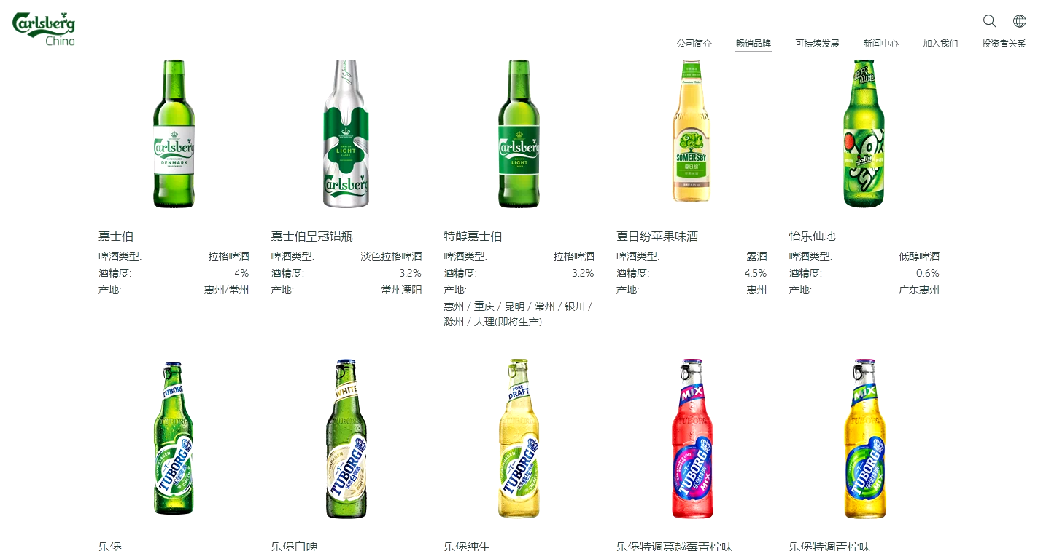
New image:
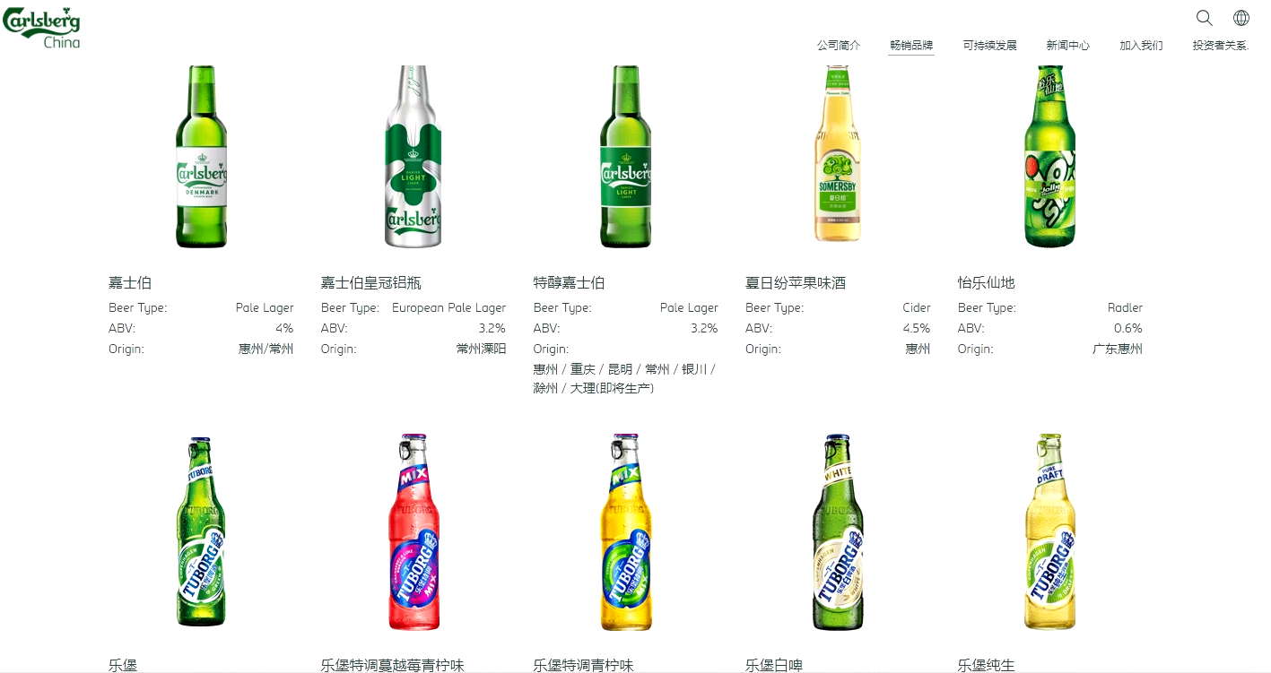
Issue 21: Title and url is different.
Old link: https://www.carlsbergchina.com.cn/zh/%E5%8F%AF%E6%8C%81%E7%BB%AD%E5%8F%91%E5%B1%95/esg/
New link: https://stage-carlsberg-group-2022.euwest01.umbraco.io/asia/cn/zh/%E5%8F%AF%E6%8C%81%E7%BB%AD%E5%8F%91%E5%B1%95/%E6%88%91%E4%BB%AC%E7%9A%84esg%E8%AE%A1%E5%88%92/
Old image:
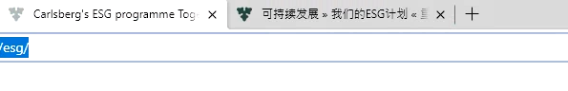
New image:
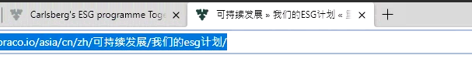

Issue 22: Title and url is different.
Old link: https://www.carlsbergchina.com.cn/zh/%E5%8F%AF%E6%8C%81%E7%BB%AD%E5%8F%91%E5%B1%95/esg/
New link: https://stage-carlsberg-group-2022.euwest01.umbraco.io/asia/cn/zh/%E5%8F%AF%E6%8C%81%E7%BB%AD%E5%8F%91%E5%B1%95/%E6%88%91%E4%BB%AC%E7%9A%84esg%E8%AE%A1%E5%88%92/
Old image:
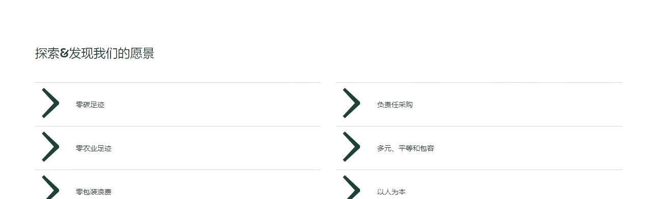
New image:
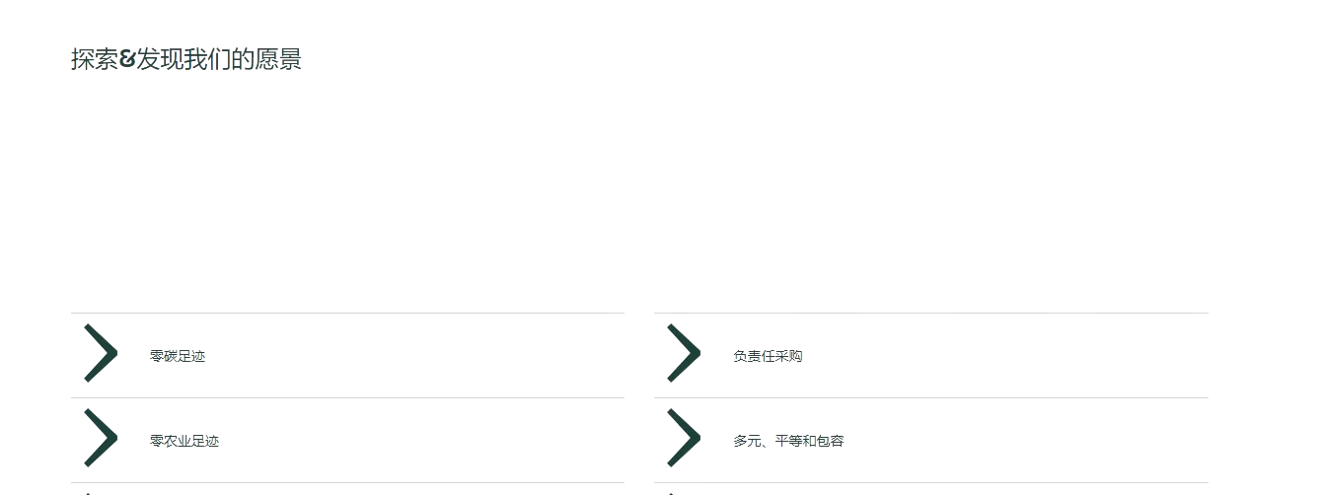

Issue 23:Links is redirect to the old website.
Old link: https://www.carlsbergchina.com.cn/zh/%E5%8F%AF%E6%8C%81%E7%BB%AD%E5%8F%91%E5%B1%95/esg/
New link: https://stage-carlsberg-group-2022.euwest01.umbraco.io/asia/cn/zh/%E5%8F%AF%E6%8C%81%E7%BB%AD%E5%8F%91%E5%B1%95/%E6%88%91%E4%BB%AC%E7%9A%84esg%E8%AE%A1%E5%88%92/
Old image:
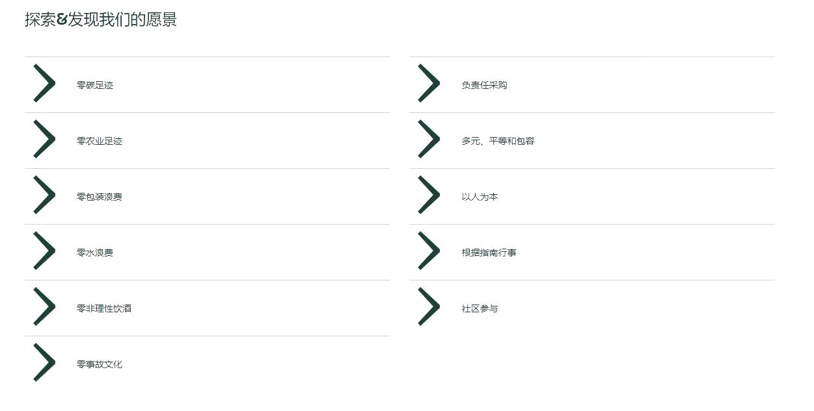
New image:
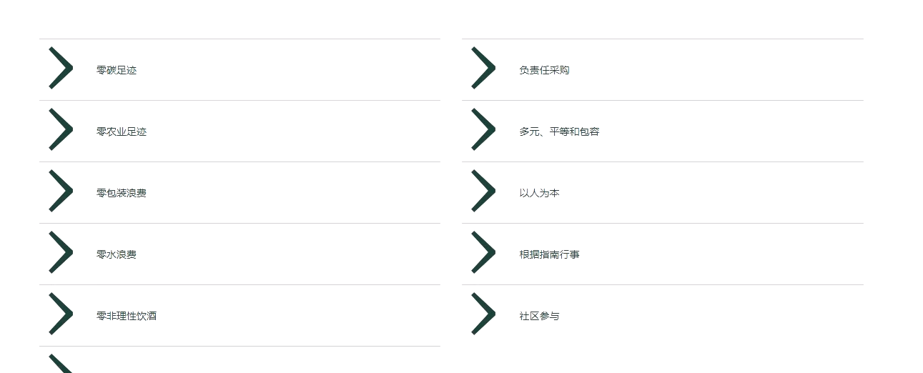

Issue 24:Links is redirect to the old website.
Old link: https://www.carlsbergchina.com.cn/zh/%E5%8F%AF%E6%8C%81%E7%BB%AD%E5%8F%91%E5%B1%95/esg/
New link: https://stage-carlsberg-group-2022.euwest01.umbraco.io/asia/cn/zh/%E5%8F%AF%E6%8C%81%E7%BB%AD%E5%8F%91%E5%B1%95/%E6%88%91%E4%BB%AC%E7%9A%84esg%E8%AE%A1%E5%88%92/
Old image:
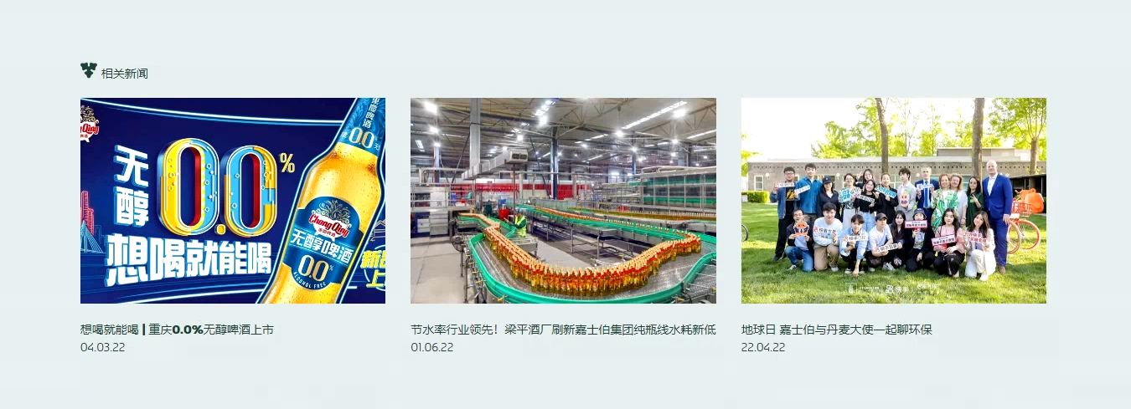
New image:

Issue 25:Image is missing need to check all the pages of Zero
Old link: https://www.carlsbergchina.com.cn/zh/%E5%8F%AF%E6%8C%81%E7%BB%AD%E5%8F%91%E5%B1%95/esg/%E9%9B%B6%E7%A2%B3%E8%B6%B3%E8%BF%B9/
New link: https://stage-carlsberg-group-2022.euwest01.umbraco.io/asia/cn/zh/%E5%8F%AF%E6%8C%81%E7%BB%AD%E5%8F%91%E5%B1%95/%E6%88%91%E4%BB%AC%E7%9A%84esg%E8%AE%A1%E5%88%92/%E9%9B%B6%E7%A2%B3%E8%B6%B3%E8%BF%B9/
Old image:
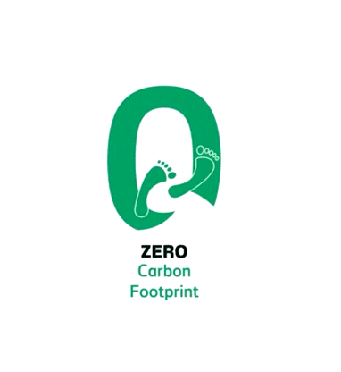
New image:
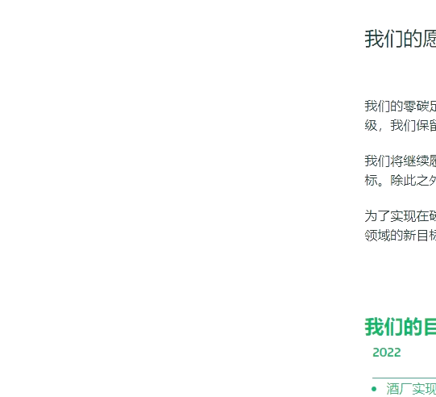

Issue 26:Extra space
Old link: https://www.carlsbergchina.com.cn/zh/%E5%8F%AF%E6%8C%81%E7%BB%AD%E5%8F%91%E5%B1%95/esg/%E9%9B%B6%E7%A2%B3%E8%B6%B3%E8%BF%B9/
New link: https://stage-carlsberg-group-2022.euwest01.umbraco.io/asia/cn/zh/%E5%8F%AF%E6%8C%81%E7%BB%AD%E5%8F%91%E5%B1%95/%E6%88%91%E4%BB%AC%E7%9A%84esg%E8%AE%A1%E5%88%92/%E9%9B%B6%E7%A2%B3%E8%B6%B3%E8%BF%B9/
Old Image:
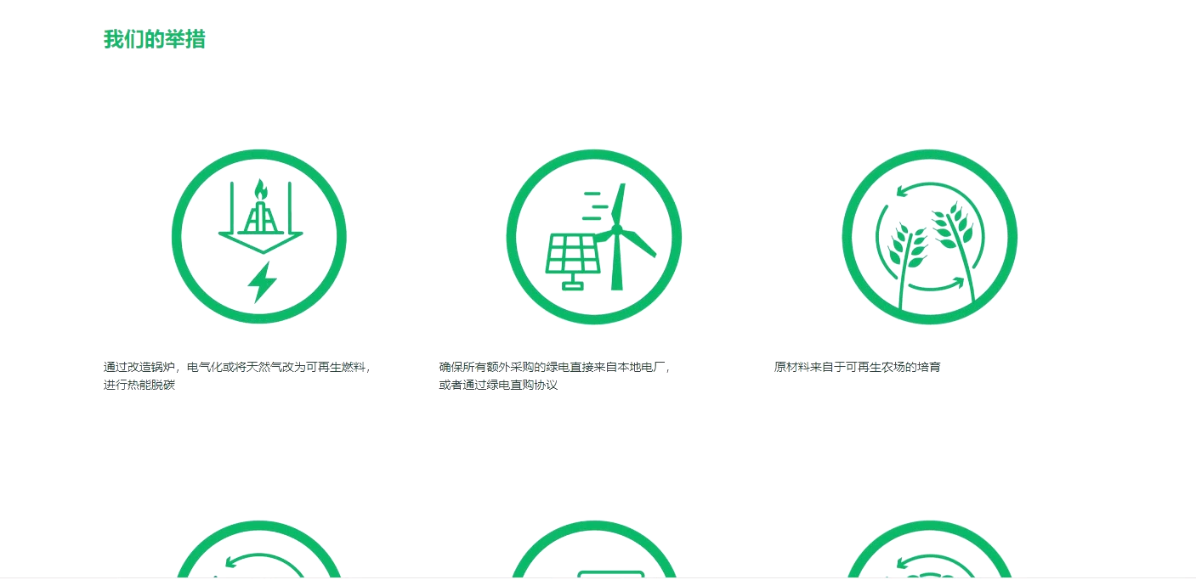
New image:
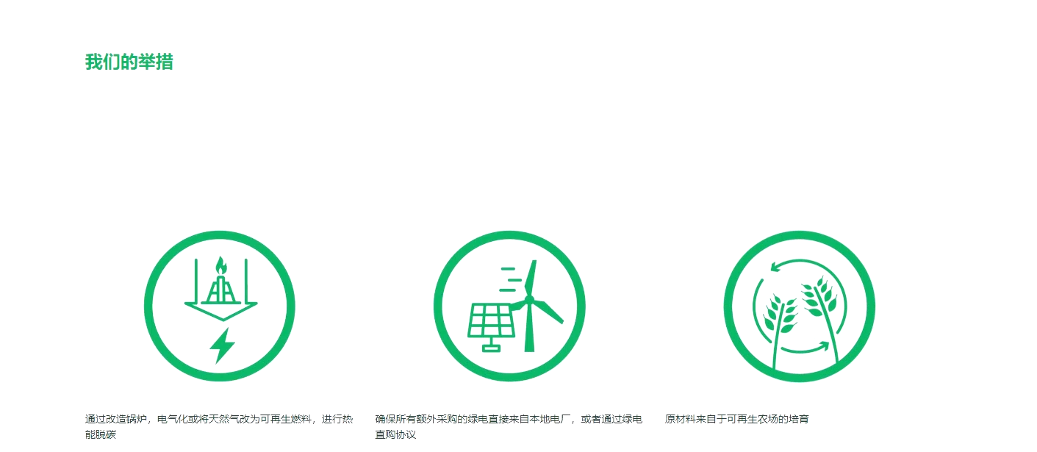

Issue 27: Issue 25 and 26 for all the zero pages.
Issue 28: The page is blank
Old link: https://www.carlsbergchina.com.cn/zh/%E5%8F%AF%E6%8C%81%E7%BB%AD%E5%8F%91%E5%B1%95/%E6%8A%A5%E5%91%8A%E5%92%8C%E6%B3%95%E8%A7%84/
New link: https://stage-carlsberg-group-2022.euwest01.umbraco.io/asia/cn/zh/%E5%8F%AF%E6%8C%81%E7%BB%AD%E5%8F%91%E5%B1%95/%E6%8A%A5%E5%91%8A%E5%92%8C%E6%B3%95%E8%A7%84/
Old image:
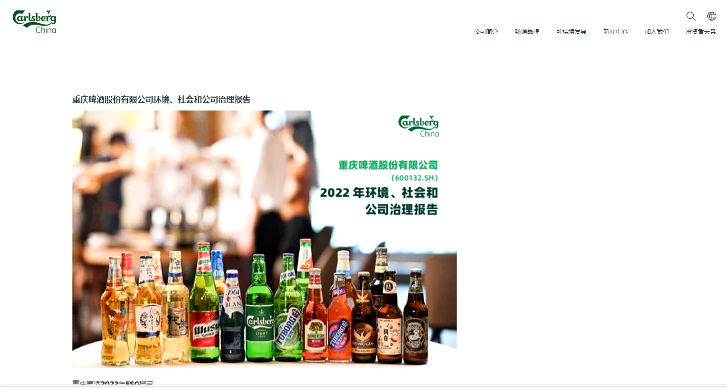
New image:
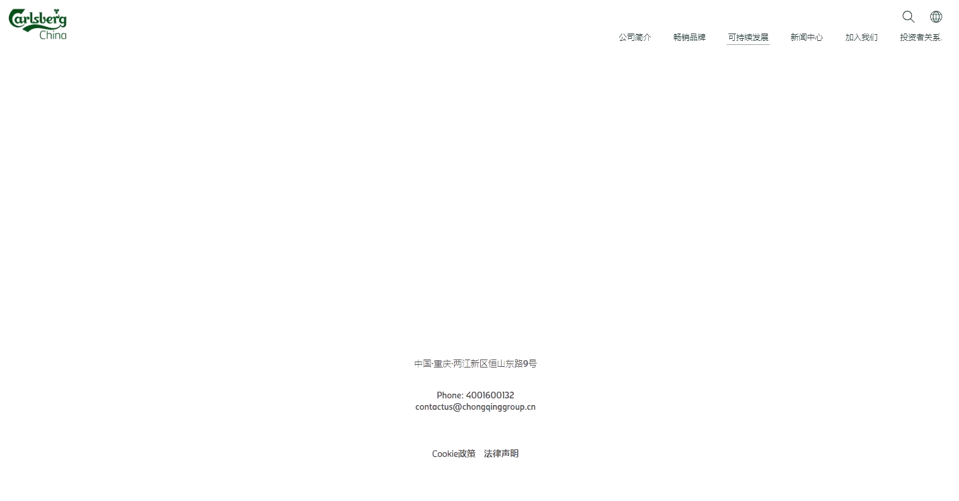

Issue 28: Both links are connected with old website.
Old link: https://www.carlsbergchina.com.cn/zh/%E5%8F%AF%E6%8C%81%E7%BB%AD%E5%8F%91%E5%B1%95/%E7%8E%AF%E4%BF%9D%E4%BF%A1%E6%81%AF%E5%85%AC%E5%BC%80/
New link: https://stage-carlsberg-group-2022.euwest01.umbraco.io/asia/cn/zh/%E5%8F%AF%E6%8C%81%E7%BB%AD%E5%8F%91%E5%B1%95/%E7%8E%AF%E4%BF%9D%E4%BF%A1%E6%81%AF%E5%85%AC%E5%BC%80/
Image:
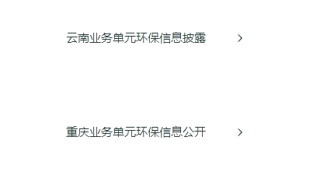

Issue 29: Both links are connected with old website.
Old link: https://www.carlsbergchina.com.cn/zh/%E5%8F%AF%E6%8C%81%E7%BB%AD%E5%8F%91%E5%B1%95/%E7%8E%AF%E4%BF%9D%E4%BF%A1%E6%81%AF%E5%85%AC%E5%BC%80/%E4%BA%91%E5%8D%97%E4%B8%9A%E5%8A%A1%E5%8D%95%E5%85%83%E7%8E%AF%E4%BF%9D%E4%BF%A1%E6%81%AF%E6%8A%AB%E9%9C%B2/
New link: https://www.carlsbergchina.com.cn/zh/%E5%8F%AF%E6%8C%81%E7%BB%AD%E5%8F%91%E5%B1%95/%E7%8E%AF%E4%BF%9D%E4%BF%A1%E6%81%AF%E5%85%AC%E5%BC%80/%E4%BA%91%E5%8D%97%E4%B8%9A%E5%8A%A1%E5%8D%95%E5%85%83%E7%8E%AF%E4%BF%9D%E4%BF%A1%E6%81%AF%E6%8A%AB%E9%9C%B2/
Image:

Issue 30: Both links are connected with old website.
Old link: https://www.carlsbergchina.com.cn/zh/%E5%8F%AF%E6%8C%81%E7%BB%AD%E5%8F%91%E5%B1%95/%E7%8E%AF%E4%BF%9D%E4%BF%A1%E6%81%AF%E5%85%AC%E5%BC%80/%E9%87%8D%E5%BA%86%E4%B8%9A%E5%8A%A1%E5%8D%95%E5%85%83%E7%8E%AF%E4%BF%9D%E4%BF%A1%E6%81%AF%E6%8A%AB%E9%9C%B2/
New link: https://stage-carlsberg-group-2022.euwest01.umbraco.io/asia/cn/zh/%E5%8F%AF%E6%8C%81%E7%BB%AD%E5%8F%91%E5%B1%95/%E7%8E%AF%E4%BF%9D%E4%BF%A1%E6%81%AF%E5%85%AC%E5%BC%80/%E9%87%8D%E5%BA%86%E4%B8%9A%E5%8A%A1%E5%8D%95%E5%85%83%E7%8E%AF%E4%BF%9D%E4%BF%A1%E6%81%AF%E6%8A%AB%E9%9C%B2/
Image:
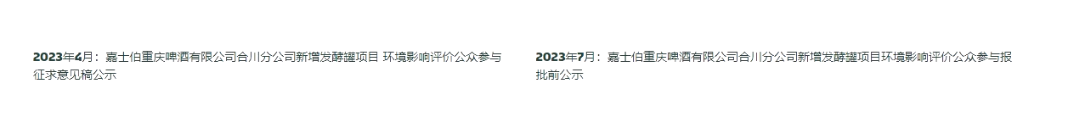
Issue 31: Image is different and also the language is different.
Old link: https://www.carlsbergchina.com.cn/zh/%E6%96%B0%E9%97%BB%E4%B8%AD%E5%BF%83/%E5%85%A8%E9%83%A8%E6%96%B0%E9%97%BB/
New link: https://stage-carlsberg-group-2022.euwest01.umbraco.io/asia/cn/zh/%E6%96%B0%E9%97%BB%E4%B8%AD%E5%BF%83/%E5%85%A8%E9%83%A8%E6%96%B0%E9%97%BB/
Old image:
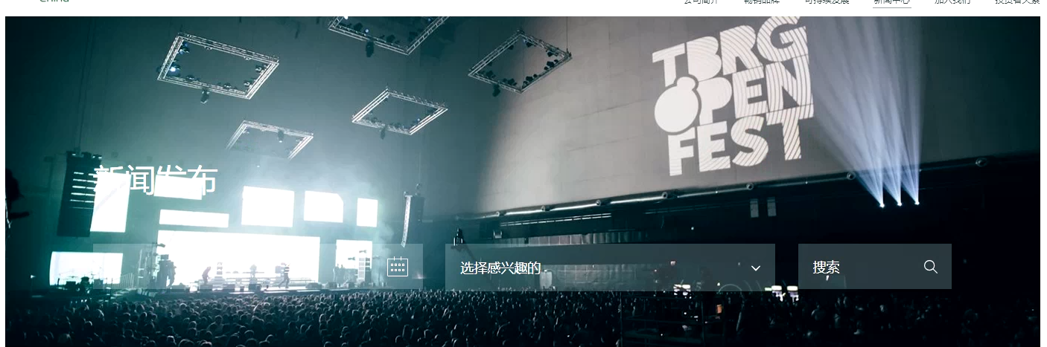
New image:
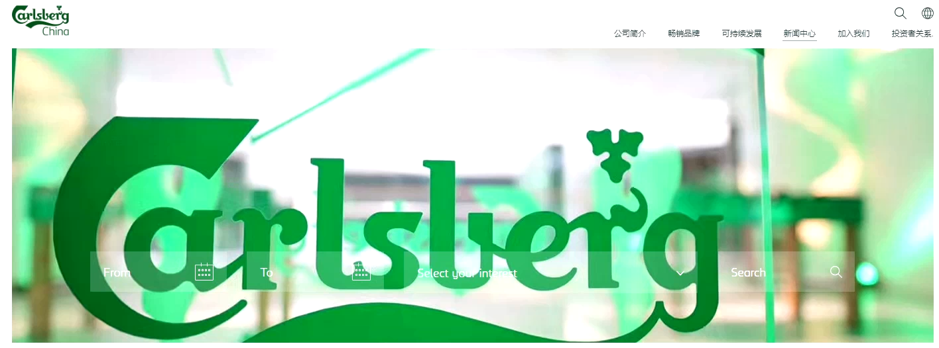
Issue 32: Language and count is different.
Old link: https://www.carlsbergchina.com.cn/zh/%E6%96%B0%E9%97%BB%E4%B8%AD%E5%BF%83/%E5%85%A8%E9%83%A8%E6%96%B0%E9%97%BB/
New link: https://stage-carlsberg-group-2022.euwest01.umbraco.io/asia/cn/zh/%E6%96%B0%E9%97%BB%E4%B8%AD%E5%BF%83/%E5%85%A8%E9%83%A8%E6%96%B0%E9%97%BB/
Old image:
New image:
Issue 33: Language and count is different in this page.
Old link: https://www.carlsbergchina.com.cn/zh/%E6%96%B0%E9%97%BB%E4%B8%AD%E5%BF%83/%E5%85%AC%E5%8F%B8%E6%96%B0%E9%97%BB/
New link: https://stage-carlsberg-group-2022.euwest01.umbraco.io/asia/cn/zh/%E6%96%B0%E9%97%BB%E4%B8%AD%E5%BF%83/%E5%85%AC%E5%8F%B8%E6%96%B0%E9%97%BB/
Image:
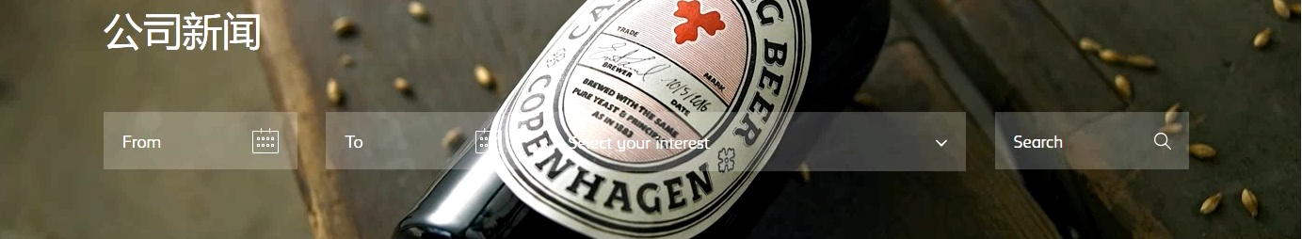
Issue 34: issue 32 in all pages for 4th option in header.

Issue 35:Extra gap
Old link: https://www.carlsbergchina.com.cn/zh/%E5%8A%A0%E5%85%A5%E6%88%91%E4%BB%AC/%E5%98%89%E6%96%87%E5%8C%96/
New link: https://stage-carlsberg-group-2022.euwest01.umbraco.io/asia/cn/zh/%E5%8A%A0%E5%85%A5%E6%88%91%E4%BB%AC/%E5%98%89%E6%96%87%E5%8C%96/
Old image:
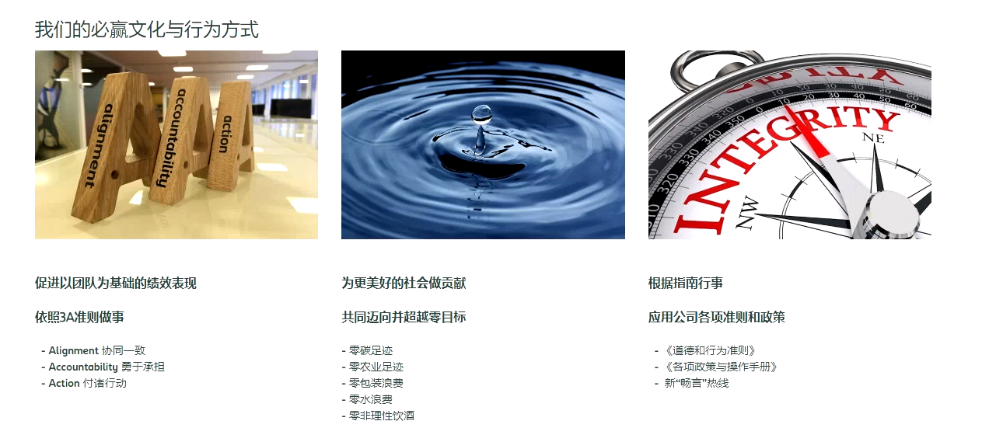
New image:
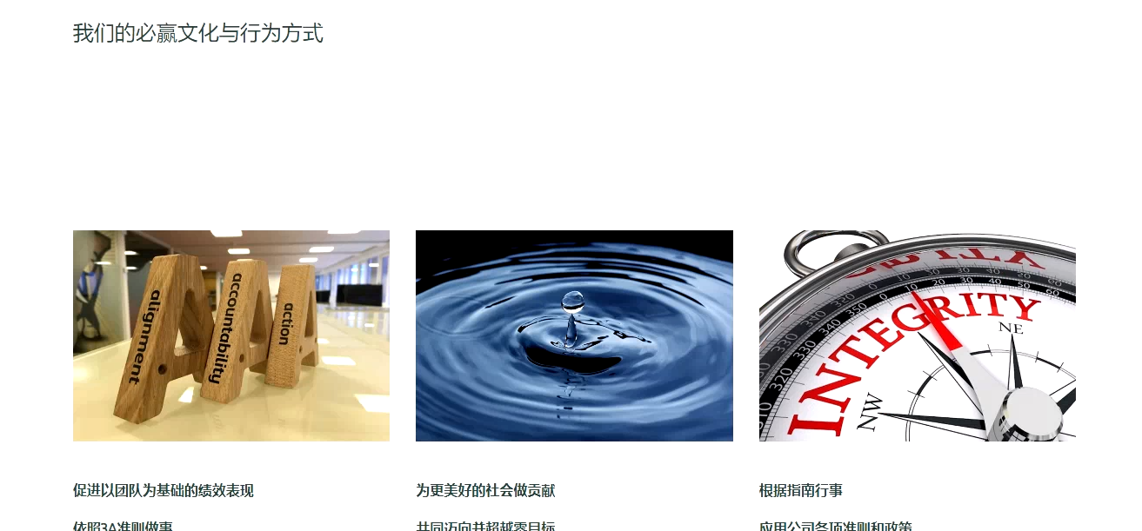
Issue 36:Extra gap
Old link: https://www.carlsbergchina.com.cn/zh/%E5%8A%A0%E5%85%A5%E6%88%91%E4%BB%AC/%E5%98%89%E6%96%87%E5%8C%96/
New link: https://stage-carlsberg-group-2022.euwest01.umbraco.io/asia/cn/zh/%E5%8A%A0%E5%85%A5%E6%88%91%E4%BB%AC/%E5%98%89%E6%96%87%E5%8C%96/
Old image:
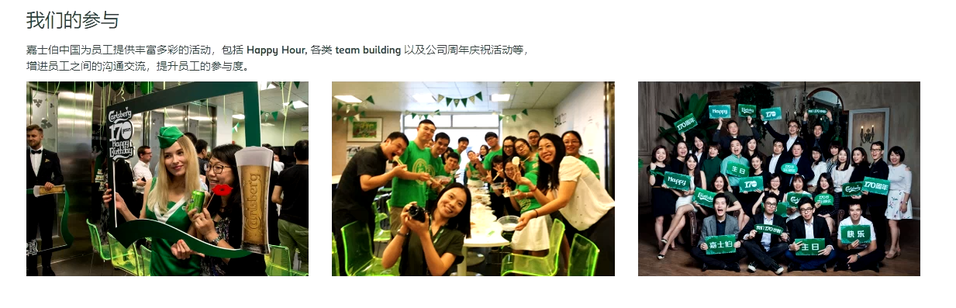
New image:
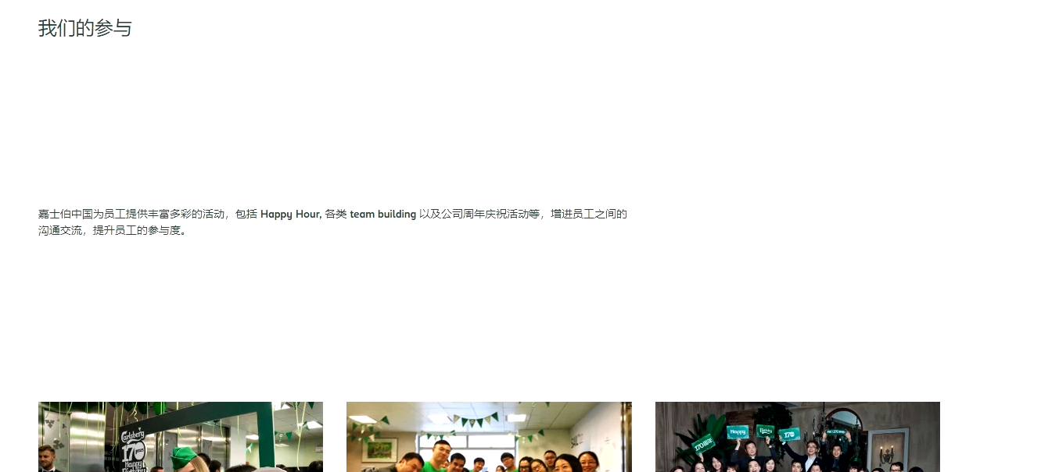

Issue 37:
Old link: https://www.carlsbergchina.com.cn/zh/%E5%8A%A0%E5%85%A5%E6%88%91%E4%BB%AC/%E5%98%89%E6%9C%89%E6%9C%BA%E4%BC%9A/
New link: https://stage-carlsberg-group-2022.euwest01.umbraco.io/asia/cn/zh/%E5%8A%A0%E5%85%A5%E6%88%91%E4%BB%AC/%E5%98%89%E6%9C%89%E6%9C%BA%E4%BC%9A/
Old image:
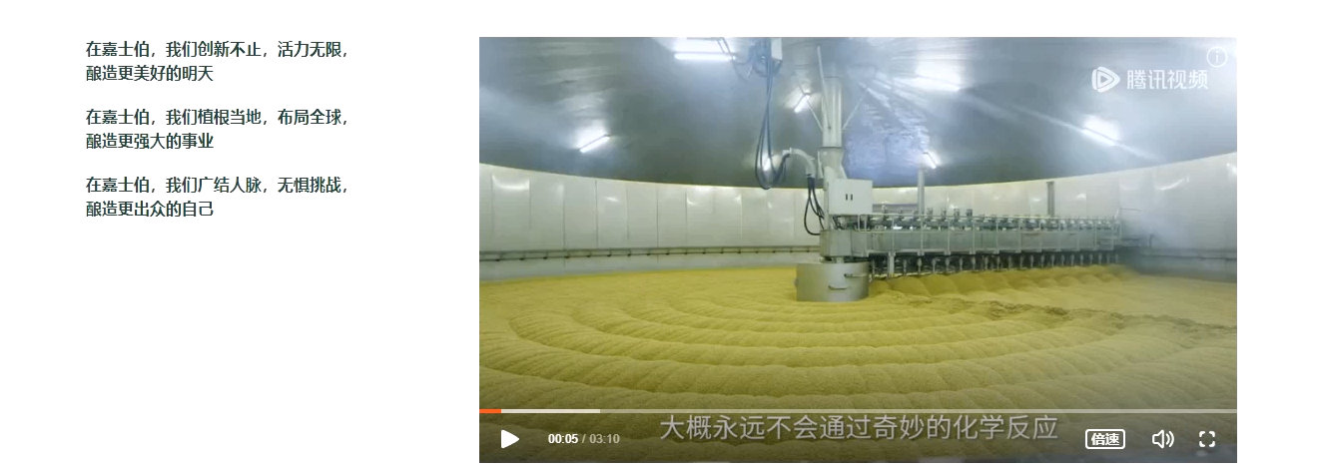
New image:
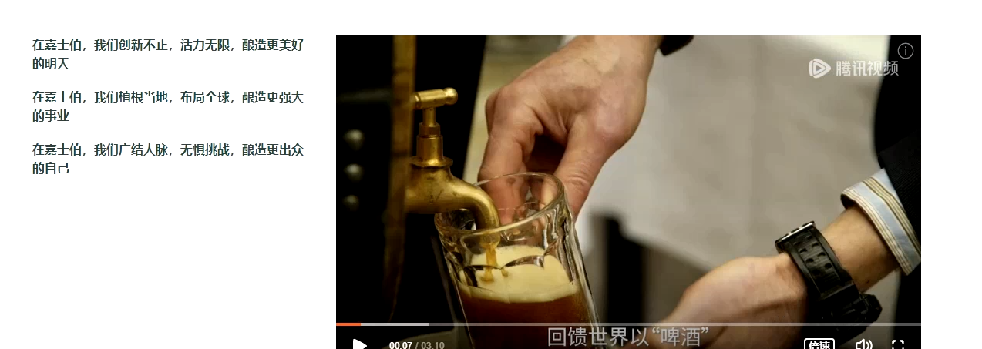
Issue 38: In header last option have no dropdown in the old one but in new one they have four option.(but it is showing oops page)
Issue 39: In header 3rd option have dropdown in first dropdown many of the option is extra.
Issue 40: In header all option in the old one is highlighted but not in the new one.(menu is same as old)
Issue 41: in footer all option is going old web.
Note: Please check all the pages for the language and alignment.

